
READ WRITE INC.
Reading feeds the imagination, it expands horizons and offers new and exciting ways of seeing and making sense of our lives and of the world around us.
Michael Morpurgo

At Blowers Green Primary School, we aim for all our children to become fluent, confident readers who are passionate about reading.
Children who read regularly or are read to regularly have the opportunity to open the doors to so many different worlds! More importantly, reading will give your child the tools to become independent life-long learners. We can achieve this together through:
- Read Write Inc, a programme to help to your child read at school.
- Encouraging children to develop a love of books by reading to them daily, at home and at school.
- Giving children access to a wide range of books at school and at home.
At Blowers Green we use Read Write Inc Phonics (RWI) to give your child the best possible start with their literacy. We have put together a guide to how the RWI programme works together with some useful links.
Please take the time to read the information as it will provide invaluable information as to how you can help and support your child in reading.
What is Read Write Inc?
Read Write Inc (RWI) is a phonics and literacy programme which helps all children learn to read fluently and at speed so they can focus on developing their skills in comprehension, vocabulary and spelling. The programme is designed for children aged 4-7. However, we will continue teaching RWI to children beyond the age of 7 if they still need support in their reading.
RWI was developed by Ruth Miskin and more information on this can be found at
https://www.ruthmiskin.com/en/parents-copy-2/
How will RWI be taught?
All children are assessed regularly by our RWI lead teachers so they work with children at the same level. This allows complete participation in lessons.
Nursery
Children will be introduced to the initial sounds in short five-minute sessions.
Reception
In Reception all children will learn how to ‘read’ the sounds in words and how those sounds can be written down. Those who are ready will begin to read and write simple words within books.

Reading
The children:
- learn 44 sounds and the corresponding letters/letter groups using simple picture prompts – see below
- learn to read words using Fred talk and sound blending
- read from a range of storybooks and non-fictions books matched to their phonic knowledge
- develop comprehension skills in stories by answering ‘Find It’ and ‘Prove It’ discussion questions
Writing
The children:
- learn to write and form the letters/letter groups which represent the 44 sounds with the help of fun phrases
- learn to write words by using Fred Talk
- learn to build sentences by practising sentences out loud before they write

Year 1 and above
Children follow the same format as Reception but will work on complex sounds and read books appropriate to their reading level. Daily sessions of RWI phonics last for one hour. Once children become fluent speedy readers they will move on to literacy lessons.

Five key principles underpin the teaching in all Read Write Inc. sessions:
Purpose – know the purpose of every activity and share it with the children, so they know the one thing they should be thinking about
Participation – ensure every child participates throughout the lesson. Partnership work is fundamental to learning
Praise – ensure children are praised for effort and learning, not ability
Pace – teach at an effective pace and devote every moment to teaching and learning
Passion – be passionate about teaching so children can be engaged emotionally.

Children will be taught how to read as follows:
Before you start to teach your child, practise saying the sounds below. These are the sounds we use to speak in English.

Fred Talk
We use pure sounds (‘m’ not’ muh’,’s’ not ‘suh’, etc.) so that your child will be able to blend the sounds into words more easily.
https://schools.ruthmiskin.com/training/view/WzM9gyE6/T7zwRIVb
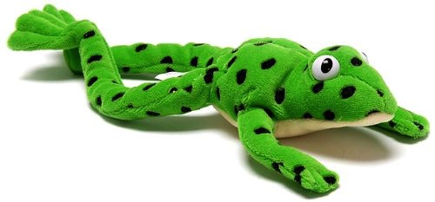
At school we use a puppet called Fred who is an expert on sounding out words! we call it, ‘Fred Talk’. E.g. m-o-p, c-a-t, m-a-n, sh-o-p, b-l-a-ck.

The children are taught the sounds in 3 sets.
Set 1 Sounds are taught in the following order together with rhymes to help children form the letters correctly and instantly recognise sounds ready for blending.
Set 1
Sound | Rhyme
m | down Maisie then over the two mountains. Maisie, mountain, mountain
a | round the apple, down the leaf
s | slither down the snake
d | round the dinosaur’s back, up his neck and down his feet
t | down the tower, across the tower
i | down the insects body, dot for the head
n | down Nobby and over the net
p | down the plait, up and over the pirate’s face
g | round the girl’s face, down her hair and give her a curl
o | all around the orange
c | curl around the caterpillar
k | down the kangaroo’s body, tail and leg
u | down and under the umbrella, up to the top and down the puddle
b | down the laces, over the toe and touch the heel
f | down the stem and draw the leaves
e | slice into the egg, go over the top, then under the egg
l | down the long leg
h | down the horse’s head to the hooves and over his back
sh | slither down the snake, then down the horse’s head to the hooves and over his back
r | down the robot’s back, then up and curl
j | down his body, curl and dot
v | down a wing, up a wing
y | down a horn, up a horn and under the yak’s head.
w | down, up, down, up the worm.
th | down the tower, across the tower, then down the horse’s head to the hooves and over his back
x | zig-zag-zig, down the zip.
ch | curl around the caterpillar, , then down the horse’s head to the hooves and over his back
qu | round the queen’s head, up to her crown, down her hair and curl
ng | A thing on a string
nk | I think I stink

Children will also use pictures for each sound to help recognise the sound and then form the shape of the sound.
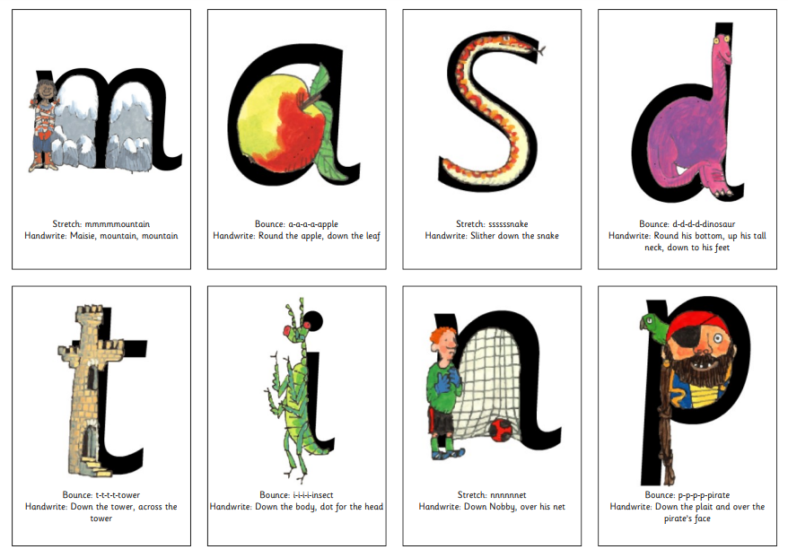
The children are then taught Set 2 Sounds – the long vowels. When they are very confident with all of set 1 and 2 they are taught Set 3 Sounds.
Long vowel sound | Set 2 Speed Sound cards  Teach these first | Set 3 Speed Sound cards
ay | ay: may I play | a-e: make a cake | ai: snail in the rain
ee | ee: what can you see | ea: cup of tea | e: he me we she be
igh | igh: fly high | i-e: nice smile
ow | ow: blow the snow | o-e: phone home | ao: a goat in a boat
oo | oo: poo at the zoo | u-e: huge brute | ew: chew the stew
oo | oo: look at a book
ar | ar: start the car
or | or: shut the door | aw: yawn at dawn
air | air: that’s not fair | are: share and care
ir | ir: whirl and twirl | ur: nurse for a purse | er: a better letter.
ou | ou: shout it out | ow: brown cow
oy | oy: toy for a boy | oi: spoil the boy
ire | ay: may I play | ire: fire fire!

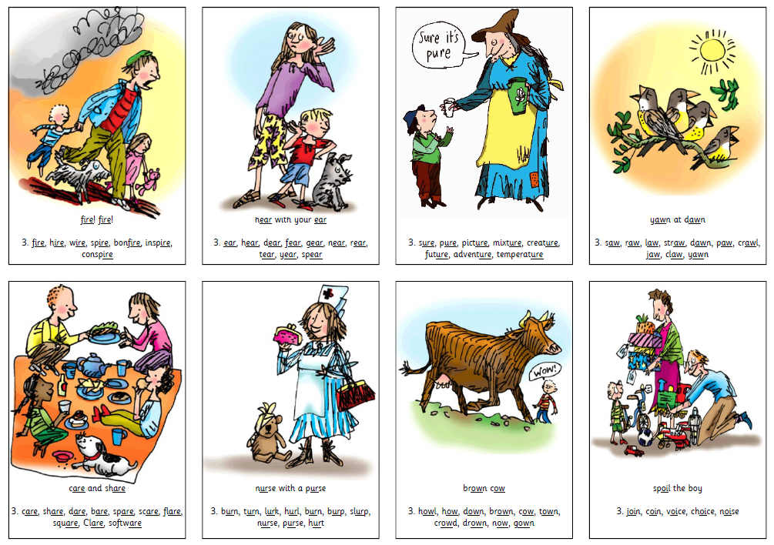

Order of Story books: Children will follow the order listed below. Children will be introduced to ‘Ditty books’ when they successfully begin to read single words. The expectation is that all children will leave Year One as confident speedy readers, ready to take on the challenges of Year Two. However, some children may need extra support and your teacher will talk to you about this.

Books | Speedy Green Words in Books
Red Ditty 1-10 | Click here to help your child
Green 1-10 | Click here to help your child
Purple 1-10 | Click here to help your child
Pink 1-10 | Click here to help your child
Orange 1-12 | Click here to help your child
Yellow 1-10 | Click here to help your child
Blue 1-10 | Click here to help your child
Grey 1-13 | Click here to help your child

To help at home:
Your child will start to bring books home when they are confident readers. Please help them to read and give lots of praise! Remember you can share the enjoyment of reading with your child using a variety of picture and story books at home.
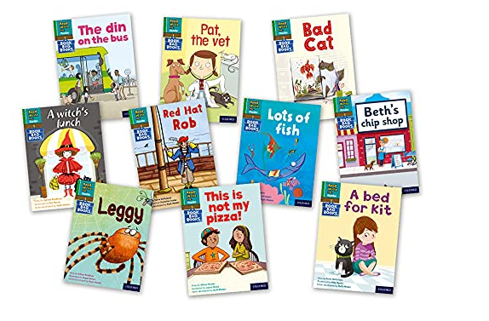
If you have any other questions about Read Write Inc, please see your child’s class teacher.

